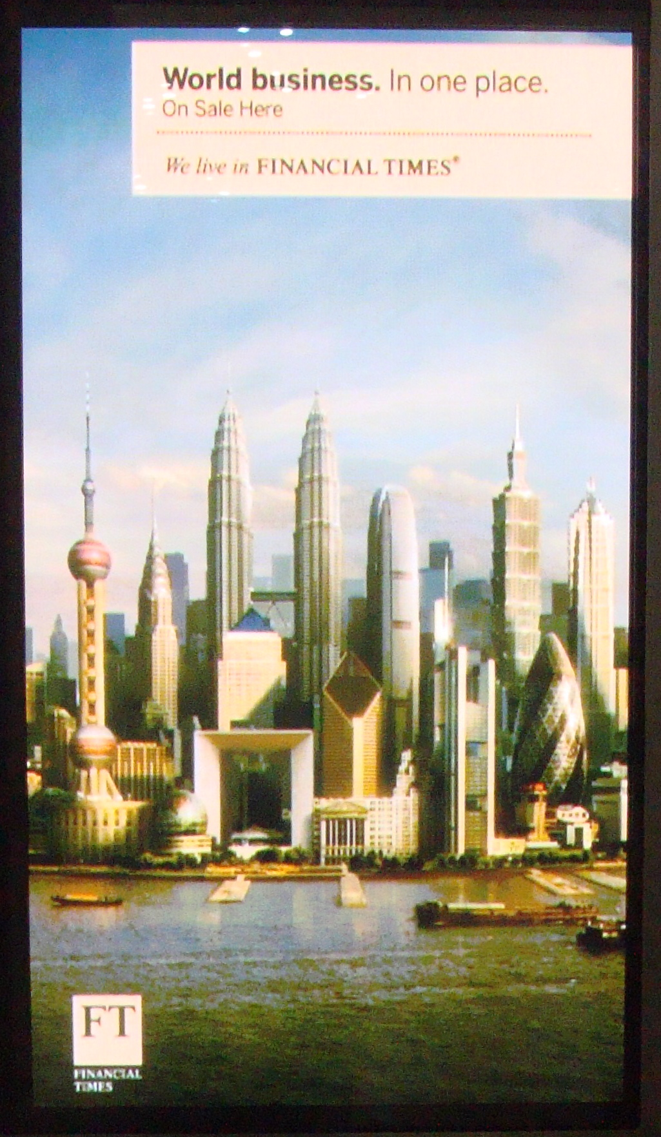
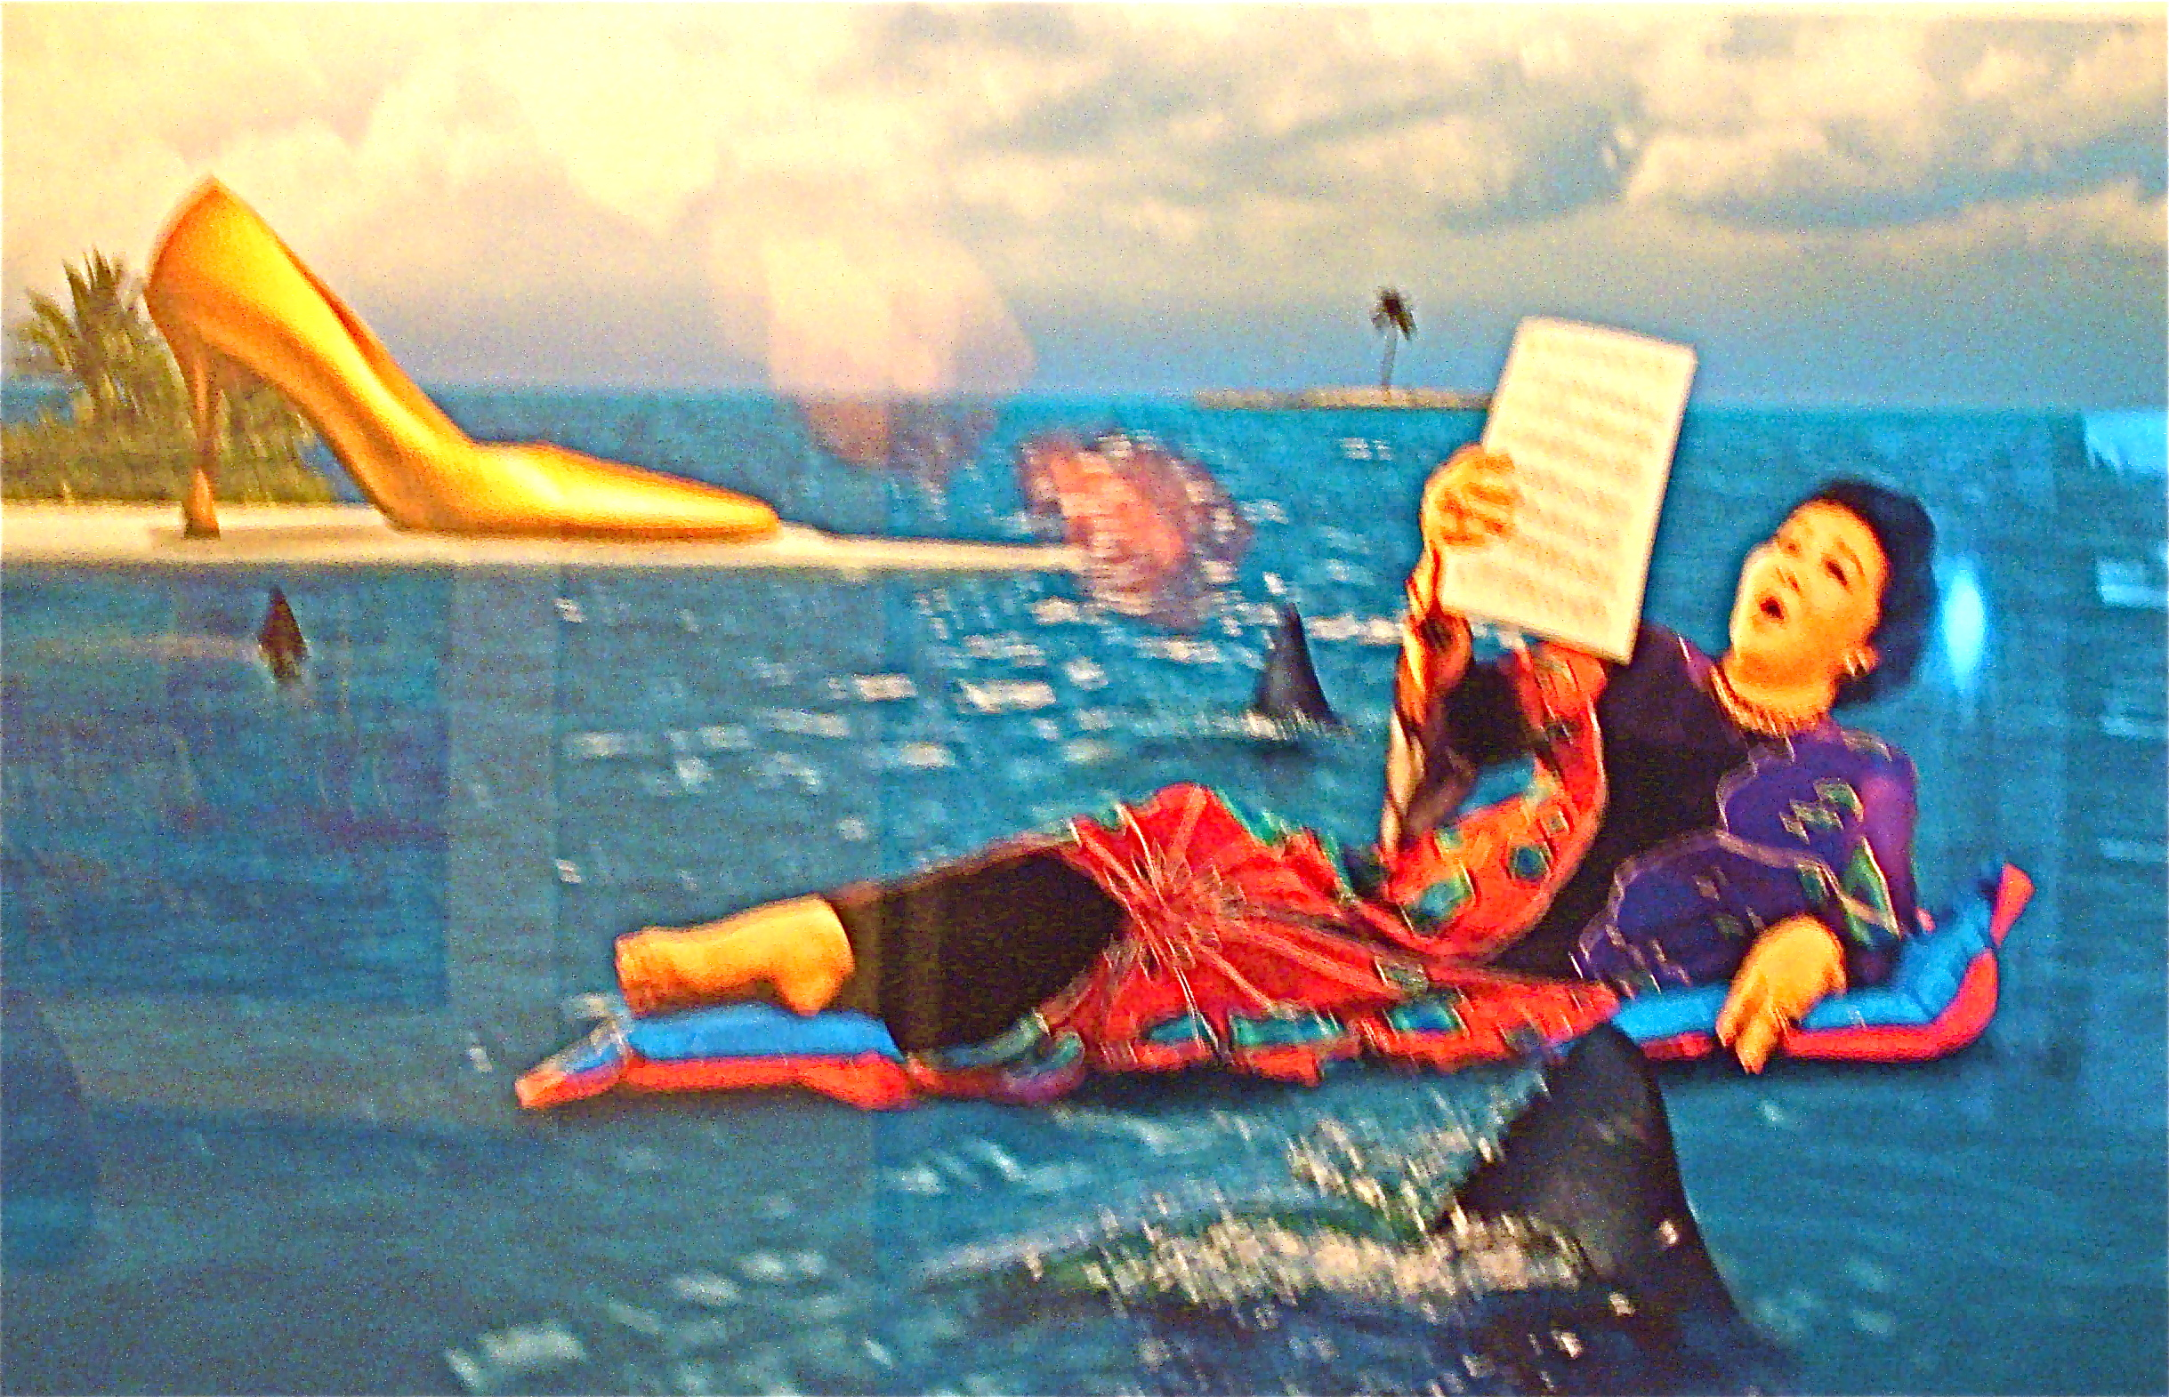

Fig 4. Imelda (Singapore Art Museum: Filippino contemporary art show) perhaps doing Gilbert and Sullivan’s Pirates of Penzance:

Although our dark career / Sometimes involves the crime of stealing,
We rather think that we're/Not altogether void of feeling.
Although we live by strife/We're always sorry to begin it,
For what, we ask, is life / Without a touch of Poetry in it?

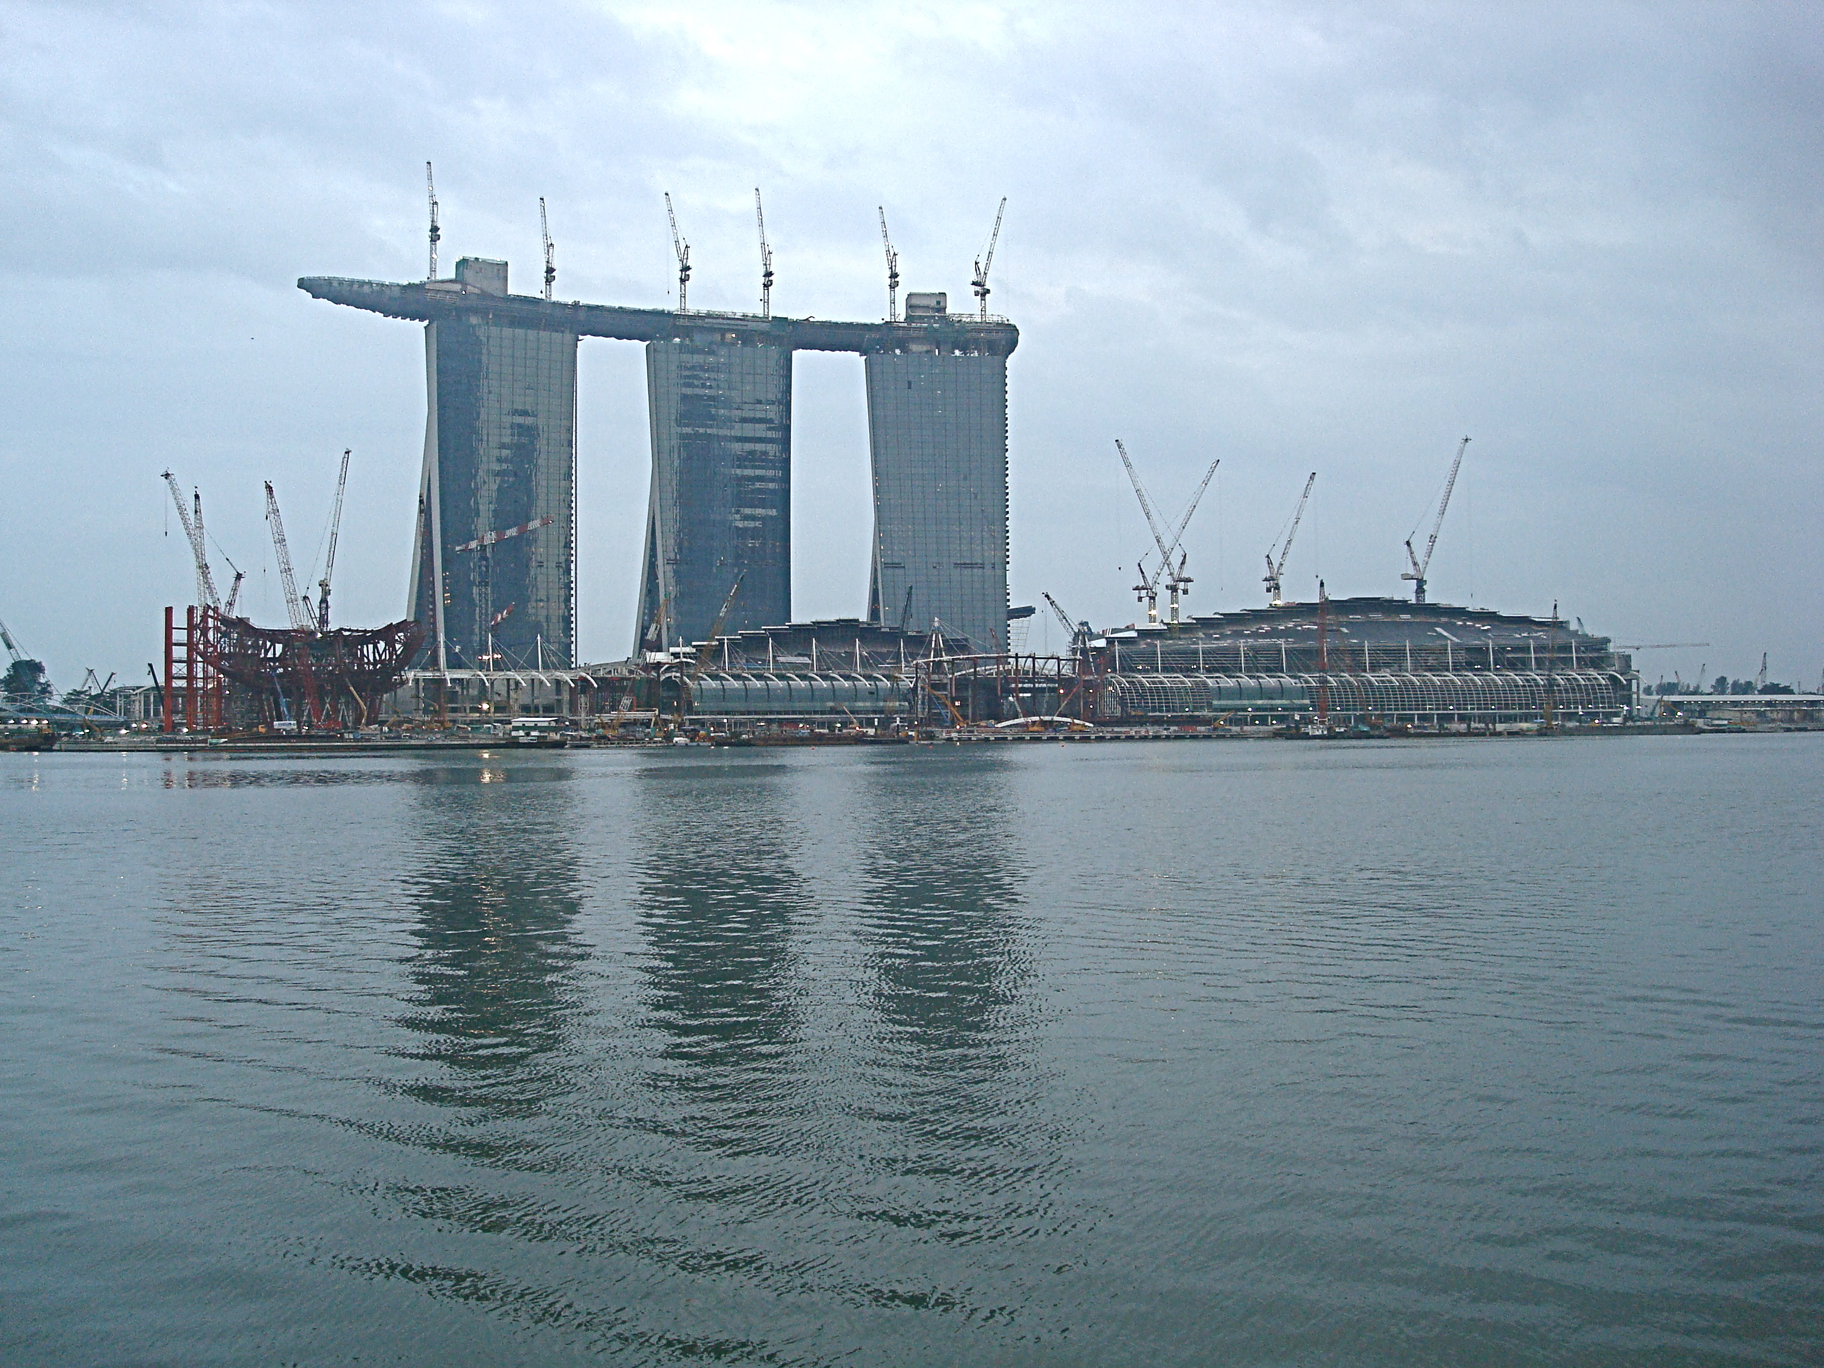
Fig. 5: Singapore: Gambling at the Ancestor Tablets? Photo MF

IV. iPAD: Side-B, Going Inside

[George’s Three Scenarios]

Documents of Accession

within [the documents of accession] are some of the starkest indices of power
hierarchies . . . how the memberships of different countries have been structured . . .
manipulation of the screens to shade, blur, make clear, and magnify (Marcus, 43)

Training in the Art of Negotiation [photos, silent videos of class sessions]

“Transparency” as Annelise Riles argues is a legal technology for setting
apart technical legal forms, apart from content. One of the techniques is
to put items for negotiation into brackets. What is visible, when negotiators
focus on what is inside the brackets are the layers and levels of language, of other documents, alternative possibilities out of which the text has been
created as proposed amendments are taken largely from documents produced at other levels. Markers of progress are notes as the amount
of the text in brackets decreases from 60% to 40% to 20%. Negotiated
language is often more “things delegates bring in” than what academics
might recognize as meaning, let alone proper grammar or elegant form.

WTO Elitelore on the Well-Functioning Judicial System of the WTO

These disputes or brewing controversies are one of the most
common topics of daily corridor talk . . . also represent the
‘spine’ of institutional memory . . . are a genre of elitelore in
which insiders regularly produce ‘para-ethnographic’ observations
. . . reminds me of how veteran ranked players recount moves and
an atmosphere of moods in famous chess matches (Marcus, p 46)

V. Conclusions: Hinge, Typanum, Archive

The terms — hinge, tympanum, archive — are, in part, Derridian philosophemes. No coincidence, Rheinberger might say, that they should fit into his historicization of epistemology, the shift to focus on the plural constitution of the sciences, which is also part of the shift I try to trace in my historization of methods and epistemologies in social theory, anthropology, culture, and genealogies of STS.

George is right to focus on the politics/theaters of positioning, on the relation between the insides (texts) and outsides (world economy) of ethnography. He is also right to draw attention to the meta-methodologies and similarities of language among many who are doing and reflecting upon contemporary ethnographies, including the natives whom we work alongside, the various native ethnographers (para-ethnographers?), corridor talk generators, and others who revise the pedagogies in which we are being trained (informally as well as formally, the hidden as well as the explicit curricula) for the future, and which the younger generation often pushes upon the older ones.

The facts are thereby unpacked and reframed, put into new settings, generate new concatenations and cascades, revealing new values. “Values” are themselves highly ambiguous, vague or empty, and polyvalent terms, deliberately so, and analytically often undecidable between inductive derivations from choices made or aspirations towards which choices are directed.

Appendix:
On the west side staircase, the labor theme in Europe continue, this time with
a mural by Sean (nee John) Keating illustrating Irish labor, a gift in 1961 by the Government of Ireland to the International Labor Organization, and used on the cover of the 2009 book celebrating the life of ILO founding figure and Irishman, Edward Phelan, on the 90th anniversary of the ILO’s founding in 1919. Set again against the back gro
und of a rural scene — a mounted fox hunter, a stone built village, stone fences along the road — oil and gas workers in jumpsuit white uniforms struggle with a large wheel of tubing, and other workers work on wiring up a generator or other machinery, an oil derrick is off to the side, and in the center is a a white tower with in and out take pipes and a red metal storage drum. In the mid ground a worker in sleeveless undershirt carries a rough wooden coffin.

As one continues up the stairs, one passes three blue tile panels (harvesting, ploughing, fishing) by Tangiers born, Portugese artist, Jorge Colaco, given by the Portuguese government to the ILO in 1928. Then there is the 2000+ tilework by Alabert Hahn Jr. (nee Albert Pieter Dijkman), an important anti-Nazi illustrator and cartoonist. It was a gift in 1926 by the Amsterdam based International Federation of Trade Unions to the ILO. It reproduces the part of the preamble to Part 13 of the Treaty of Versailles that became the constitution of the ILO, and has at its center a stylized red and black male figure in a flying karate chop, emphasizing one supposes the power of the hands.

A few itches here to scratch might be the hidden names and signs of connections.

Finally, Marcus fantasizes staging his installations in two public spaces: the entry under the Maurice Denis (and Sean Keating) painting (s), and in the open cafeteria space whose walls are graced with three 1940 murals of Swiss-French artist Gustave-Louis Jaulmens commissioned for the ILO: “Dans la joie universelle” (in the universal joy), “Le travail dans l’abondance” (work in a world of bundance) and “Le Bienfait des Loisirs” (the benefits of leisure). These are neo-classical panels of women (and little girls) dancing, harvesting, and picknicking, respectively, more thus about the fruits of labor than labor itself.

Dean Cornwell’s murals, commissioned for the Samuel Gompers room of the old ILO building, some of which are no longer extant, are more fully focused on work: mining, repairing generators and large machines, sewing, car repair, construction, baking, tailoring, child rearing — all in colorful hyperrealist cartoon style, very clean, and very white (no Chinese railroad labor, no Mowhawk skyscraper labor, no black autoworkers, no Mexican agricultural labor).

Other signs. The graphics of the WTO pamphlet, “The WTO Building: The Symbolic Artwork of the Centre William Rappard, Headquarters of the World Trade Organization” are as resonant as anything on the walls of the building: a strong and colorful 1930s style of typography.

But, it’s all very interesting: WTO is not about labor, but trade. The library is said to have photographs and other materials on trade: would indeed be nice to turn the library inside out, making its materials available on a smart wall in interactive form as Marcus suggests.

